CommunityDemographics2017Percent_vw

View returns expected columns (22 of them)

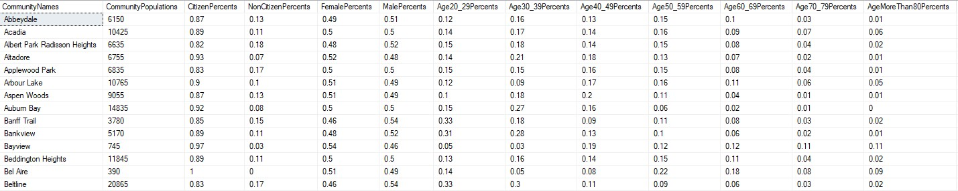

Rows retrieved 198 rows (as expected)

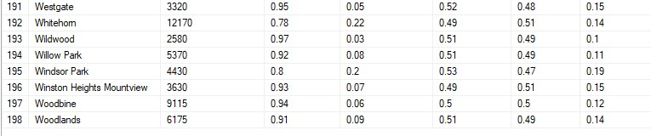

Distinct Communities 198 (as expected)

Only NULL found in Seton record (as expected)

